Alexies Farinas

CIT 180 – 1001 Spring 2021

May 2, 2021

Assignment #7

# INTRODUCTION

This database will provide information of cars that were made by car makers in Japan. This database is important, because it will provide us with information about what manufacturers are in Japan and what car models are created.

# Database Model

This database consists of four tables: Manufacturer Car Type, Car Model, and Car Detail. PK will indicate the Primary Key for the table, and FK will represent the Foreign Keys. The lines will indicate the relationship between the tables.

* Each Manufacturer can have many Car Type(s), Car Type can have many Manufacturer(s).
* Each Car Type can have many Car Model(s), Car Model(s) can have only one Car Type.
* Each Car Model can have many Car Detail(s), Car Detail(s) can have only one Car Model.

Although the Manufacturer are the ones that provide the Car Details, there is no direct connection between the Manufacturer and Car Detail. In this database, Manufacturer and Car Detail are only related by being connected to a specific Car Type and Car Model.

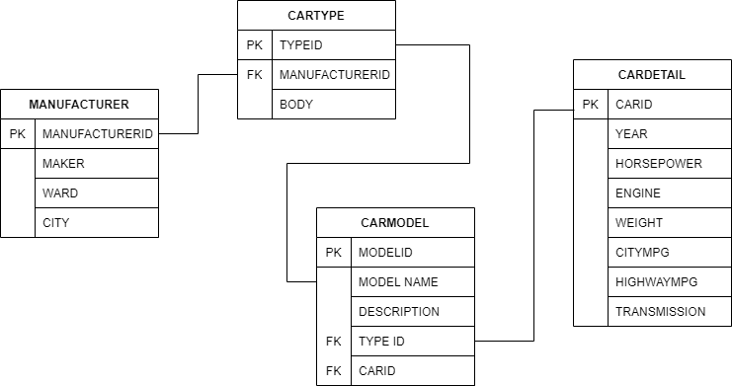

# DATABASE TABLES

**MANUFACTURER TABLE**

The Manufacturer Table consists of basic information about the manufacturer. The key to the table is **ManufacturerID**. The other information in this table are Maker and Headquarters. Maker will be the name of the company that manufactures the cars. Headquarters is where they reside in Japan. There are no foreign keys. There are approximately 14 manufacturers in Japan.

**CAR TYPE TABLE**

The Car Type Table consists of information of the body of car whether it be a sedan, SUV, etc. The primary key to this table is **TypeID**. The foreign key in this table is **ManufacturerID.** This will be referring to the Manufacturer Table.

**CAR MODEL TABLE**

The Car Model Table consists of information of the model’s name and description of the car. The primary key to this table is **ModelID**. There are two foreign keys in this table: **CarID** and **TypeID.** This will reference The Car Type Table and the Car Detail Table

**CAR DETAIL TABLE**

The Car Detail Table consists of information of the Miles per Gallon(MPG) in both city and highway, horsepower, weight, engine, transmission, and year of the Car Model. The primary key to this table is **CarID**. There are no foreign keys.

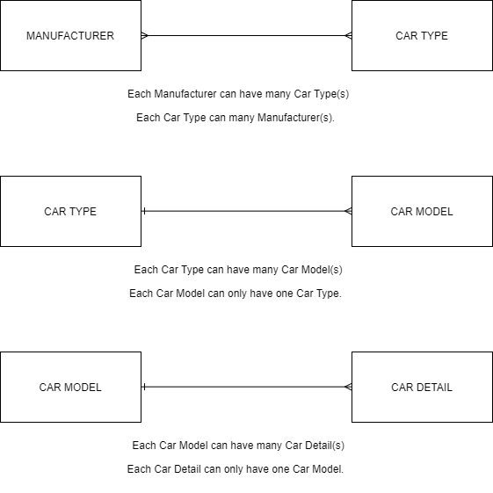

4. For this certain database, I would use a Client/server architecture. As stated in the PowerPoint, other Automotive industries can view this database. So, this database will be online. A company can access the online database through a web browser, which initiates a request to the database server. The Business logic will provide the output to the client for a display.